Synopsis
Through several projects we have experienced that a generic HW platform including basic peripherals, is suitable for a lot of different embedded system applications.
For that reason we want to develop a basic embedded computer solution, which we will offer our customers as a cheap, flexible and very “time-to-market” friendly platform.

This basic embedded computer solution shall include both a generic HW board and a SW framework, which will enable up to have a given prototype running for demonstration in a very short time period.

The solution must of course supply the most basic functionality used in an embedded computer, moreover the solution must be extendable with new HW interfaces, such as new communication media, e.g. CAN bus, GSM modem etc.

HW platform

The HW candidate for the project is the TS-7200 SBC from Technologic systems.
The TS-7200 is a full featured SBC based on the ARM9 CPU and provides a standard set of on-board peripherals, including:

- 200 MHz ARM9 processor with MMU
- 32 MB of High Speed SDRAM
- PC/104 expansion bus
- 2 COM ports
- 10/100 Ethernet interface
- Compact Flash Card interface
- Watchdog timer, SPI bus

The TS-7200 is a cheap and flexible solution and includes the basics we are looking for. It includes the PC/104 expansion bus, which makes it highly flexible regarding extensions.
Moreover Technologic systems supplies a wide range of extension boards to be used in conjunction with the TS-7200, which also makes is very interesting in a business point of view.

The TS-7200 is part of Technologic systems TS-7XXX family and it is therefore possible, with minimal overhead, to upgrade the system to run on either of these, e.g. if a faster CPU is needed on a specific project.

SW platform

The TS-7200 is shipped with a Linux OS, TS-Linux – Based on the “Busy Box” distribution, installed on the internal flash. The TS-Kernel is based on the 2.4.26 Linux Kernel.
In order to get real-time support, the kernel must support full pre-emptive scheduling. According to the documentation, the TS-Kernel is real-time capable through RTAI, however some configuration of the kernel is needed.

To support portability and to create a “simple” interface to the basics of a running embedded program, a software framework must be implemented. This framework shall consist of an OSAL and provide means for flexible communicating between tasks in the program.
The framework shall be developed in C++ and encapsulate the rather verbose C API to the POSIX compliant OS interface.
It must support a uniform way of using tasks, synchronizing mechanisms, timers, communication channels, and watchdog.

System layers:
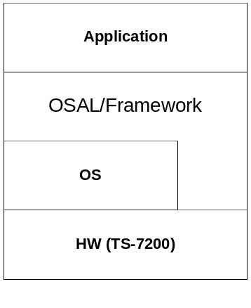

Objectives
The objectives of the project are:

- Configuring the TS-Kernel to support the basic OS functionality
- Applying real-time capabilities to the TS-Kernel through RTAI.
- Verify and test the real-time performance of the TS-Kernel run on the TS-7200 board.
- Select a subset of the POSIX API to be used in the SW framework.

